# Method 1: Payment via Mobile Account

## -Passenger selects payment option in his/her profile.

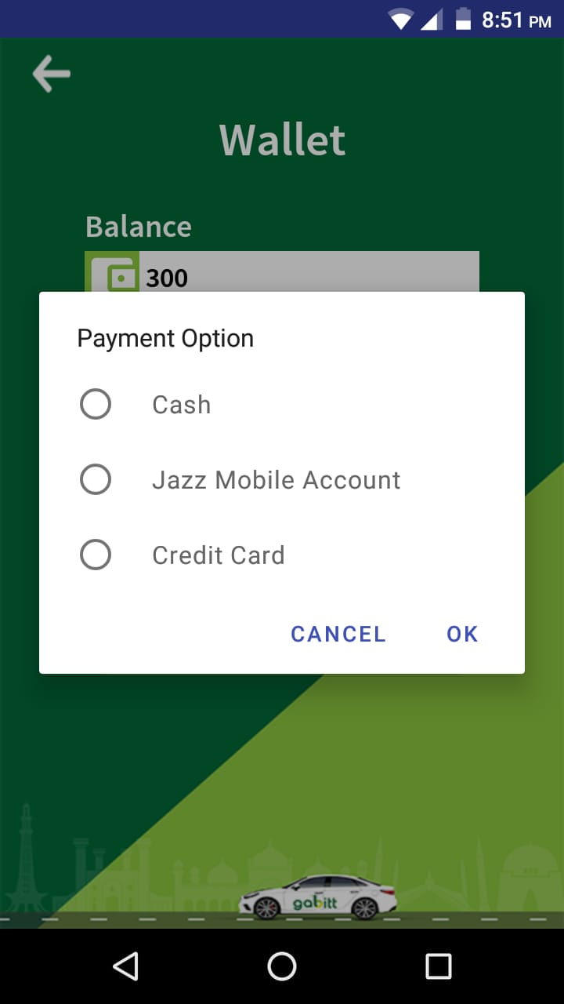

## -When driver ends the ride after trip completed, passenger app opens Jazz cash window.

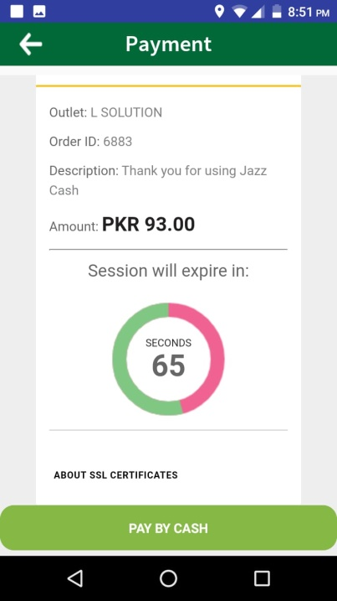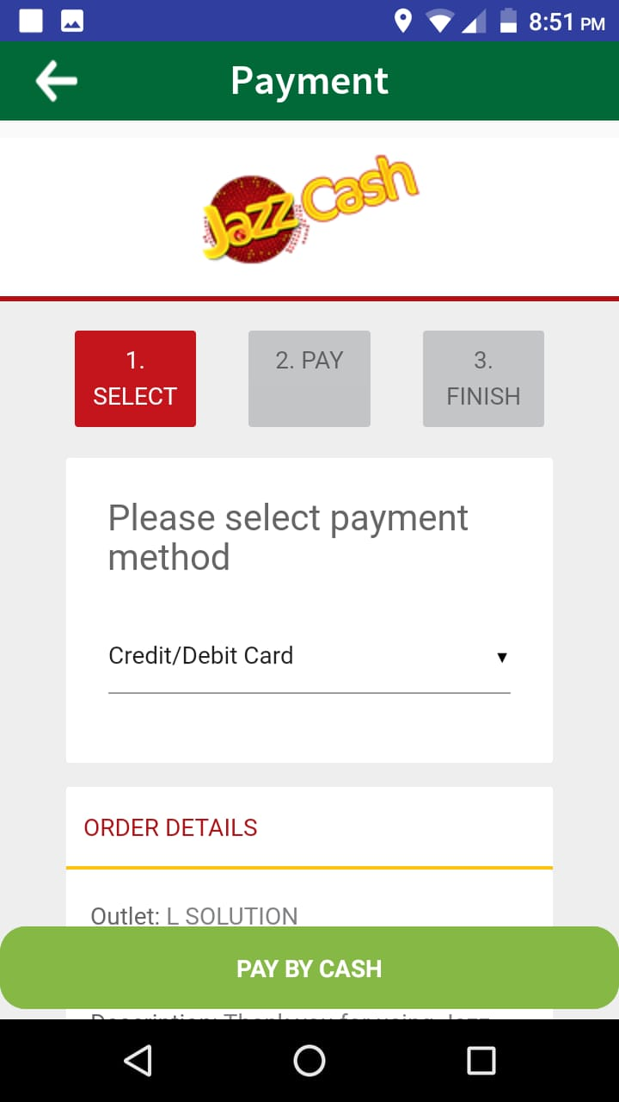

## -Passenger selects the payment method and proceeds.

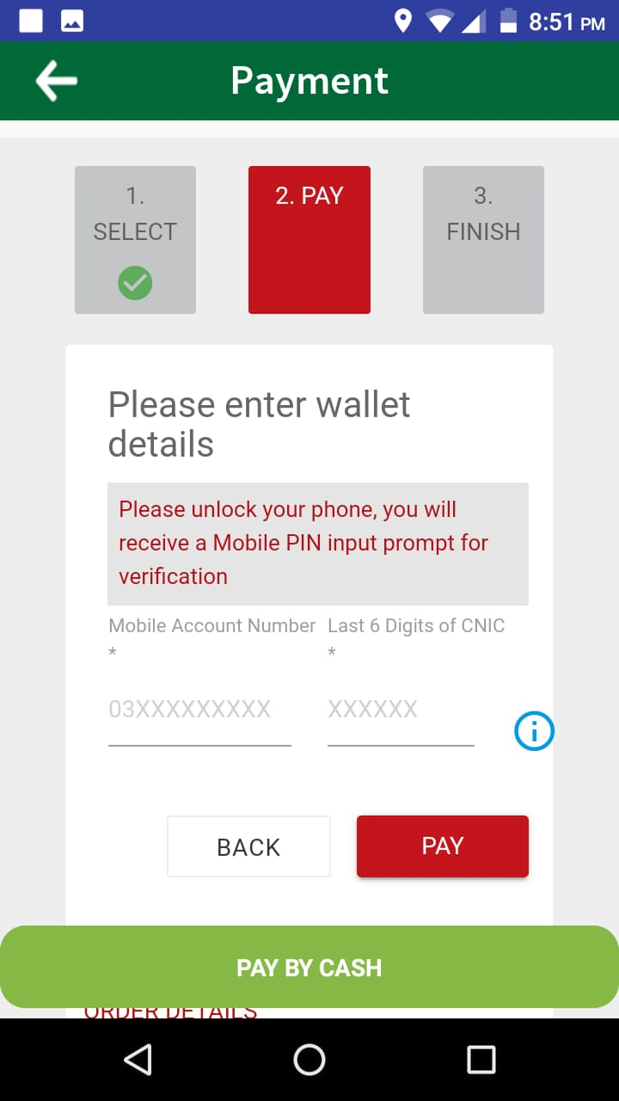

## -Passenger enters his/her account number and click “Pay”.

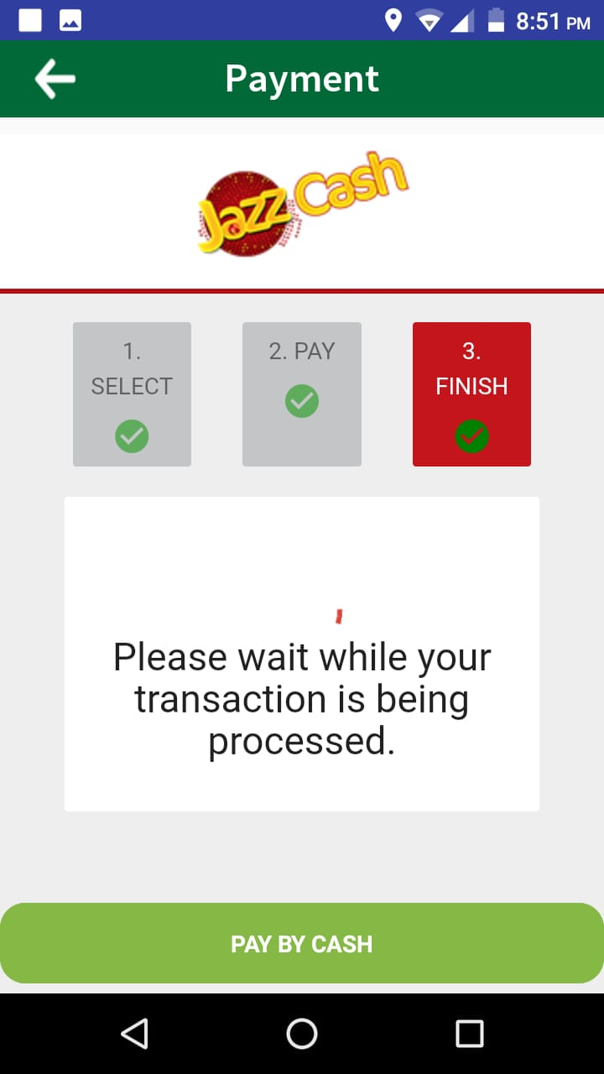

## -Jazzcash processes the transaction.

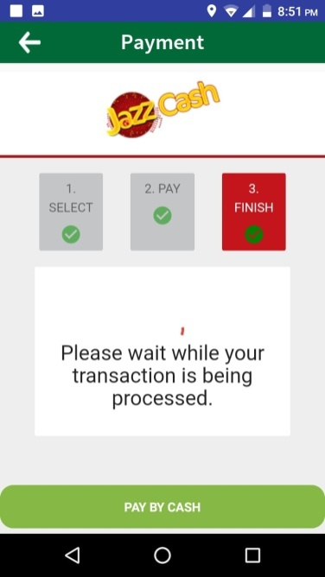

## -Jazzcash transaction successful notification and transaction stored in db.

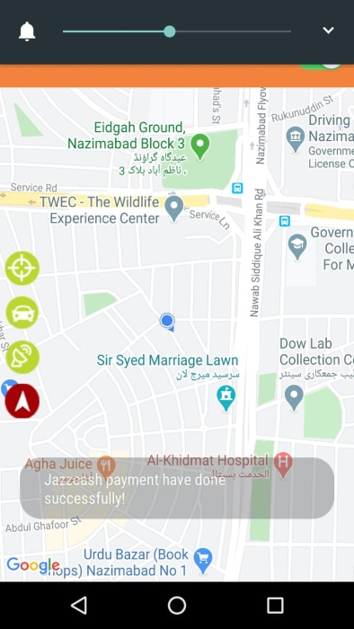

## -After successful transaction, passenger is asked to rate driver, last step

## C:\Users\Home\Downloads\WhatsApp Image 2020-06-26 at 9.54.01 PM.jpeg.

## -Merchant Panel Status

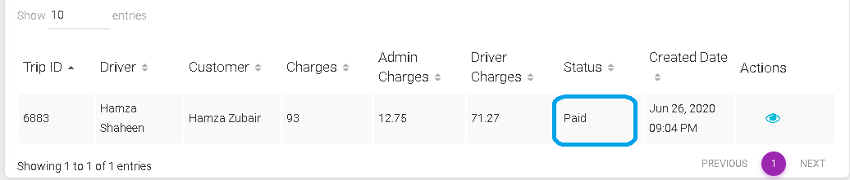

# Method 2: Payment via Credit/Debit Card

## -Passenger selects payment option in his/her profile.

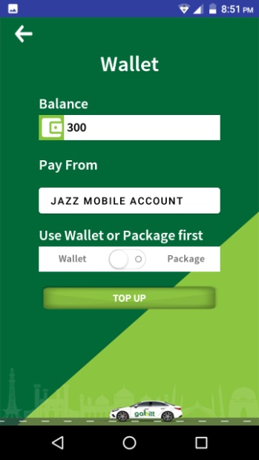

## -When driver ends the ride after trip completed, passenger app opens Jazz cash window.

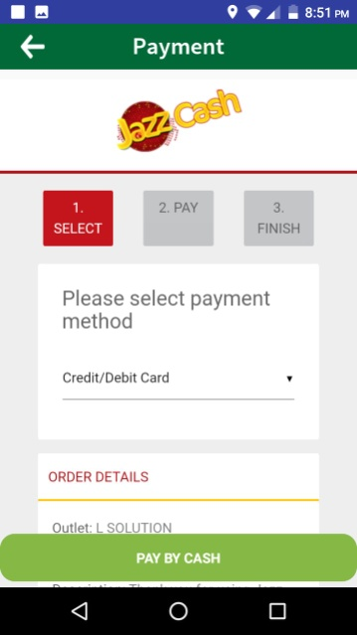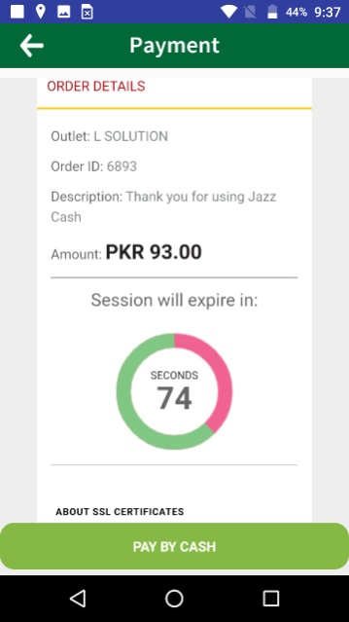

## -Landing Page

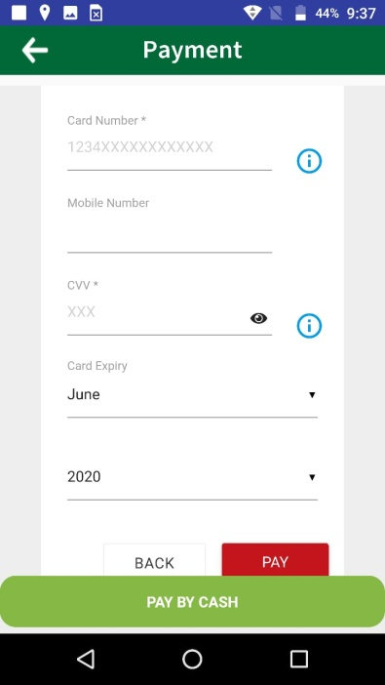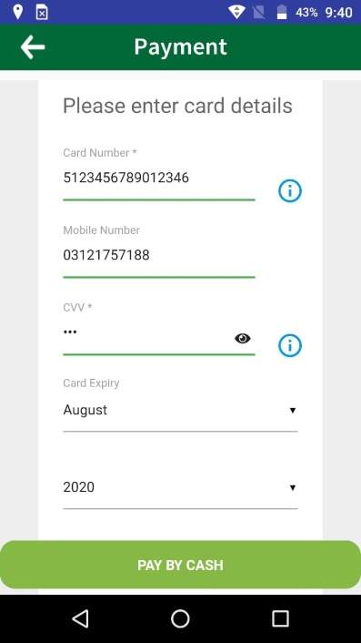

## -Payment

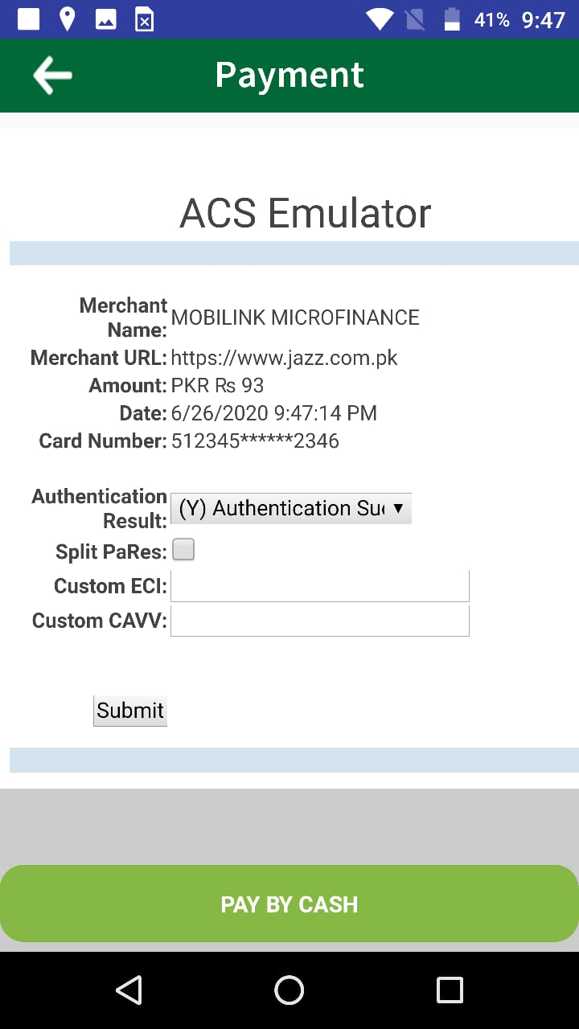

## -Invoice generated after successful payment through Credit Card.

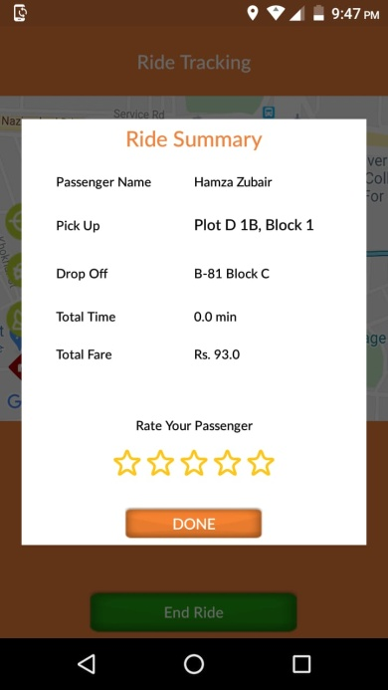

## -Merchant Panel Status

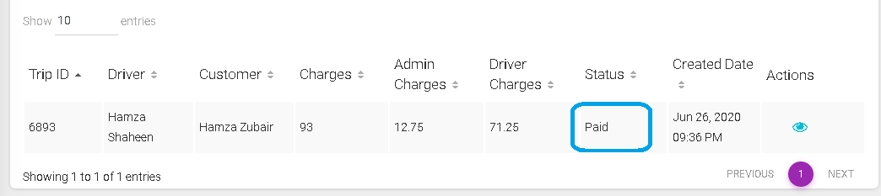

***End Of Document***